

Title: **Project task# 2**

**Subject:** Human Computer Interaction

**Submitted To:** Dr. Zubair Malik

**Submitted By:**

Zeeshan Muzammal   (BSCS13010)

Arslan Ahmad   (BSCS13023)

Ayesha Asghar   (BSCS13033)

AbdulMonam   (BSCS13039)

Submission Date:

March 20, 2017

Table of Contents

Title: 1

**POV Development** 3

POV-1 3

POV-2 3

POV-3 4

HMW Generation 4

HMW for POV-1 4

HMW for POV-2 5

HMW for POV-3 5

Best HMWs 6

Brainstorm Solutions: 6

Best Solutions: 8

Testing: 12

Things that worked 12

Things that not worked 12

# **POV Development**

## POV-1

**WE MET:**

Fahad Rana, Business Student don’t have any interest related to news. He do go through news some time when some other change the channels or he found out newspaper accidently.

**Amazed to realize:**

He hate news. He said I don’t care what is happening around us. What other politician are doing. And what is happening around us. He don’t want news related to this.

We are amazed to know that he think “everything is lie in the news”. He said “I believe on what I see with my eyes are what seems argumentative to me”.

**Game Changing to:**

It will be game changing one day he would think news are not lie (fake).

## POV-2

**WE MET:**

Mohabbat Ali, CS student. Watch news channel daily. Listen almost 5 news bulletin in a day. He visit almost 6 different type of channel. He enthusiastically follow news. He also read newspaper daily and almost newspaper of 3 different type.

**Amazed to realize:**

Amazed to realize he spend **a lot of time for news**. In our thinking he is wasting a lot of time. He said some news channels are biased to some specific society. Some are biased for some special personalities. Some channels are **biased for some politicians**. He has to visit a lot of news channels **for unbiased ness**

**Game Changing to:**

It will be game changing if he get actual news on one channel. It will save his time.

## POV-3

**We Met:**

We met rana usman, cs-student who follow different pages on social sites to get news and updates about society or world.

**Amazed to realize:**

Sources from where he get news are social sites. He used to follow different pages so sometimes news from different channels contradict with each other, so the pages he used to follow consider them biased and not trustworthy.

**Game changing to:**

Providing a platform which provide unbiased news and public point of view gets importance.

# HMW Generation

## HMW for POV-1

Q1: How might we create importance of news in his mind?

Q2: How might we create awareness about issues happening around him as a news?

Q3: How might we present news in a way to remove factor that they are not valid?

Q4: How might we create habit to take interest in news?

Q5: How might we make them feel that news source is credible? (Because they think that news are fake)

Q6: How might we make him feel that news are reality?

Q7: How might we learn that why he is not interested in news?

Q8: How might we make him realize that news is a good source of knowledge?

Q9: How might we make him feel that news are good source for general knowledge?

Q10: How might we make him feel that news are learning curve for his life?

Q11: How might we create awareness about importance of news and about issues of news channels?

## HMW for POV-2

1. How might we provide news of all channel at one place?
2. How might we save his time?
3. How might we provide un- influential news?
4. How might we reduce biasness of news channels?
5. How might we give overview of all newspaper only once at a time (together)?
6. How might we stop him from visiting a lot of channels?
7. How might we make him realize that news are not biased?
8. How might we provide him un-biased newspaper so he don’t need to visit other newspaper
9. How might we provide him alternate of other sources?
10. How might we help him to trust a specific news provider over others?

## HMW for POV-3

1. How might we build trust among people for news related program?
2. How might we let people know about importance of their point of views?
3. How might we will able to provide unbiased news?
4. How might we differentiate between biased and unbiased news?
5. How might we help him to figure out news is biased towards particular party?
6. How might we help him to validate that news general public providing is valid?
7. How might we inform that news is biased towards specific issue?
8. How might we convince user about correctness of particular news?
9. How might we reduce biasness of the data we provide?

# Best HMWs

Q.1 How might we stop him from visiting a lot of channels by providing news on one platform to save his time?

Q.2 How might we provide him un-biased newspaper related to his interest so he don’t need to visit other newspaper and visit only once at a time (together)?

Q.3 How might we create awareness about importance of news and about issues of news channels?

# Brainstorm Solutions:

**Q.1 How might we stop him from visiting a lot of channels by providing news on one platform to save his time?**

**Possible Solutions:**

* + 1. Provide a new news channel that should be unbiased
    2. A news channel that show overview of all a news in term of news obtained by all channels
    3. Get video of a news from all channels related to o news and provide that on website
    4. Get news through any source and provide news on website as a written form
    5. Providing a website where people will talk about a news and and as majority will be talking about it so it would be an unbiased

Q.2 **How might we provide him un-biased newspaper related to his interest so he don’t need to visit other newspaper and visit only once at a time (together)?**

**Possible Solutions:**

1. Provide central platform which will contain all sorts of information
2. Personalize newspaper which can be attracting part in platform
3. Combine all news of newspaper in such a way that they will feel they have overview of all news paper
4. Get information about their interest and always make a e-paper format and and put the content of news based on majority voting
5. A website on which news of all newspaper is accumulated.
6. On that website he can select his interest and can get all news according to his need.
7. He should select a credible source of news and most accurate source of news so, that he could refrain from other news sources.
8. News accumulative on one blog
9. Video sources on which all news are presented at one time.

Q.3 **How might we create awareness about importance of news and about issues of news channels?**

**Possible Solutions for 3rd:**

1. Through social sites
2. Awareness campaigns
3. Target more active and trustworthy people to communicate problem/issue
4. Through blogs by giving different examples
5. TV shows of popular channels
6. Ads on TV and radio
7. Plan different events
8. Magazines and newspapers
9. Personally visits communities and aware people

# Best Solutions:

**Solution #1:**

How might we stop him from visiting a lot of channels by providing news on one platform to save his time?

Get news through any source and provide news on website as a written. Providing a website where people will talk about a news and as majority will be talking about it so it would be an unbiased

**Solution #2:**

How might we provide him un-biased newspaper related to his interest so he don’t need to visit other newspaper and visit only once at a time (together)?

Personalize newspaper which can be attracting part in platform and based on news from all news channels

**Solution #3:**

How might we create awareness about importance of news and about issues of news channels?

Through social sites

Through Social Site

**Prototype #1:**

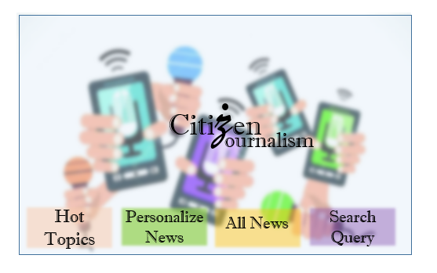

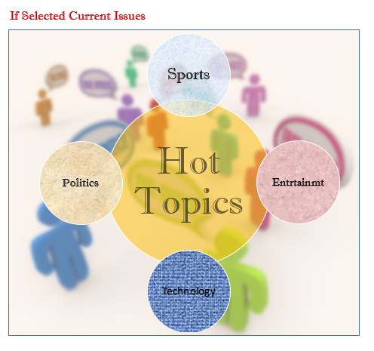

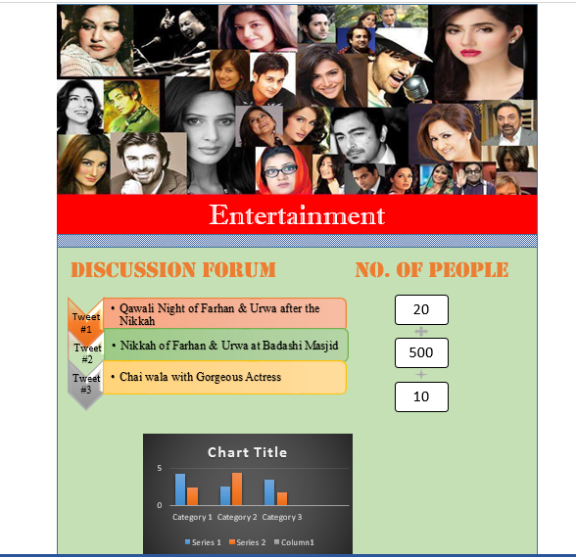

**Prototype #2:**

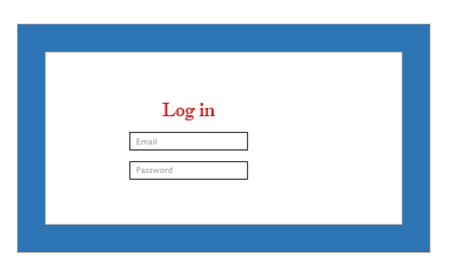

Citizen Journalism

Search for query

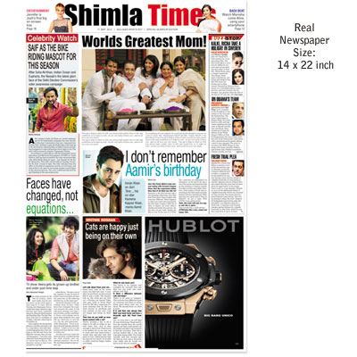

**Prototype #3:**

Entertainment

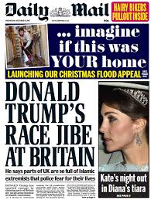

Link http: ….



Link http: ..

Next Page

Previous page

# Testing:

We tested with three users. These were same people whom we interviewed. We met at their work place they were happy to see low fidelity after interviews

## Things that worked

* Like news presented in graphs
* Part they like about prototype was personalized news
* Make no errors almost while using mockups
* Create log in easily using mockups

## Things that not worked

* They were not much comfortable with heavy texts
* Do not want tweets of different personalities
* Want concise form of news extracted from those tweet